Powerslave 12 Volts

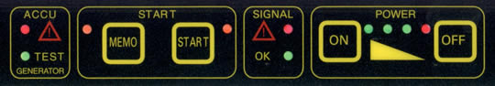

POWER | Turning ON and OFF the Power Pack.  The green led’s display the power reserve of the internal battery.  When you puch the ON, the voltmeter shows the internal battery voltage for 10 seconds. Then the voltage on the terminals  If only the red led lights up, the Power Pack is blocked and has to be charged.  AUTO POWER OFF turns the Power Pack off after 1 minute of inactivity.
SIGNAL | This block indicates whether the Power Pack is connected correctly to the engine or not.  If the green led lights up the connection is OK so you can push the START button Voltmeter gives the tension on the terminals  If the red led lights up the start button will be blocked.  - No connection.  - Wrong polarisation (+/--).  - Short circuit.  - Tension on the clamps is higher than 14,5 volts
START | When the green led lights up, you can push the start button to transmit the starting current during 150 seconds.  After that the battery will be tested.  12 start button Works between 0,1V and 14,6V
EMERGENCY PROGRAM | When the car has NO BATTERY or THE TENSION IS LESS THAN 0,1VOLTS, you can start the engine if you push the START BUTTON FOR 3 seconds.
ACCU | When this red led flashes and you hear a beep-tone, the Power Pack has to be charged immediately to avoid damage of the internal battery.  Or the booster is overheated
TEST GENERATOR  MEMO Button | If the green led lights up, the generator of the car is OK (load tension 13,6 v)  When You wanted to change the battery of your car ,then You can keep the code of the radio and the alarm of the car in memory  Put the cable in the cigarlighter and the other side in your power pack.(Or with the OBDII cabel ) Push the MEMO button and then there is now a tension of 12v on the car  This output is via a automatic fuse protected 8amps on the right side of the box

