Powerslave Electronics 12 & 24 Volts

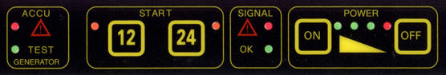

POWER | Turning ON and OFF the Power Pack.  The green led’s display the power reserve of the internal battery.  If only the red led lights up, the Power Pack is blocked and has to be charged.  AUTO POWER OFF turns the Power Pack off after 1 minute of inactivity.
SIGNAL | This block indicates whether the Power Pack is connected correctly to the engine or not.  If the green led lights up the connection is OK so you can push the START button (12V or 24 V).  If the red led lights up the start button will be blocked.  - No connection.  - Wrong polarisation (+/--).  - Short circuit.  - Tension on the clamps is higher than 14,5 volts for 12V and 28,8 volts for 24V.
START | When the green led lights up, you can push the start button (12V or 24V) to transmit the starting current during 70 seconds.  After that the battery will be tested.  12 start button Works between 0,1V and 14,6V  24 start button Works between> 15V and 28,8V for tension under < 15V use emergency program
EMERGENCY PROGRAM | When the car has NO BATTERY or THE TENSION IS LESS THAN 0,5 VOLTS, you can start the engine if you push the START BUTTON FOR 3 seconds.
ACCU | When this red led flashes and you hear a beep-tone, the Power Pack has to be charged immediately to avoid damage of the internal battery.  Or the booster is overheated
TEST GENERATOR | If the green led lights up, the generator of the car is OK (load tension 13,8V or 26,6V).

